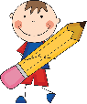First Grade Supply List for the 2023-24 School Year 

$40 Class Fee (cash or check made out to Spanish Springs Elementary) – money will be used to purchase all individual classroom supplies such as spiral notebooks, journals, pencils, glue, tissue, scissors, crayons, erasers, sharpies, art/holiday projects, classroom incentives, ink, expo markers, folders, etc.

Common Supply list for ALL first grade:

* Water bottle with flip top lid (to reduce water spills)
* Backpack